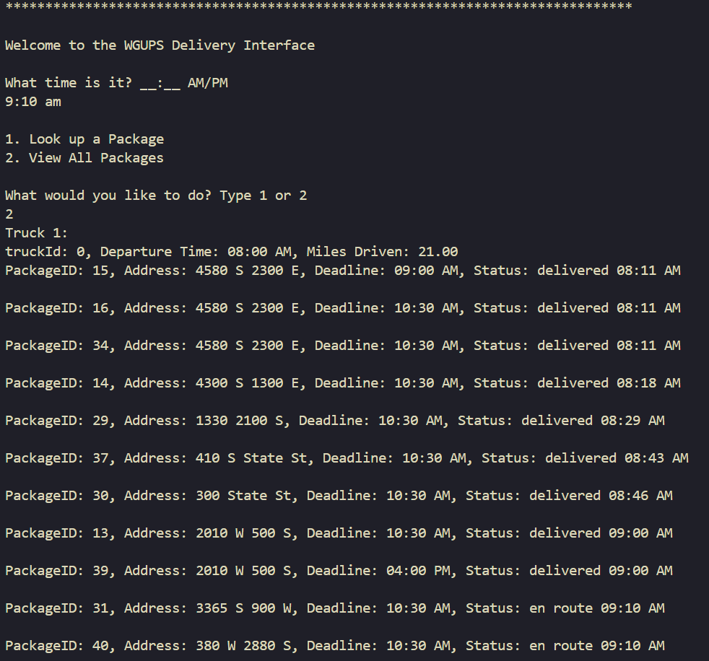

**G1**

All Packages on Each Truck

Time: 9:10 AM

Total Miles Driven = 22.50 mi

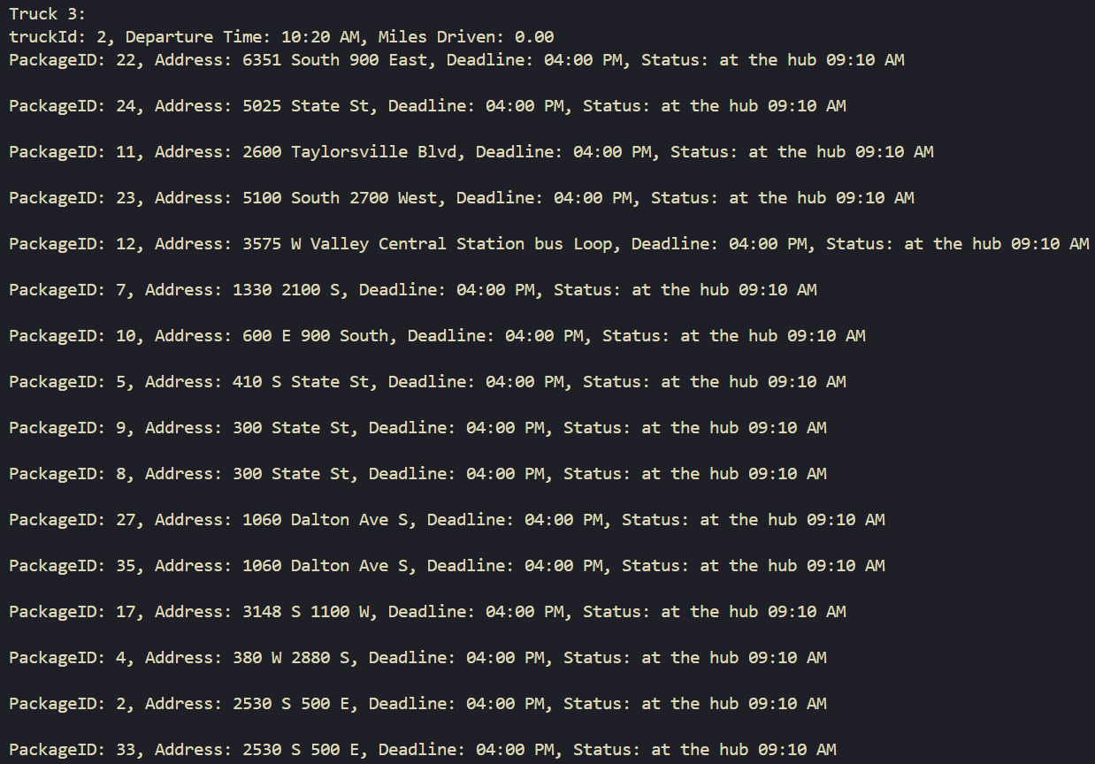

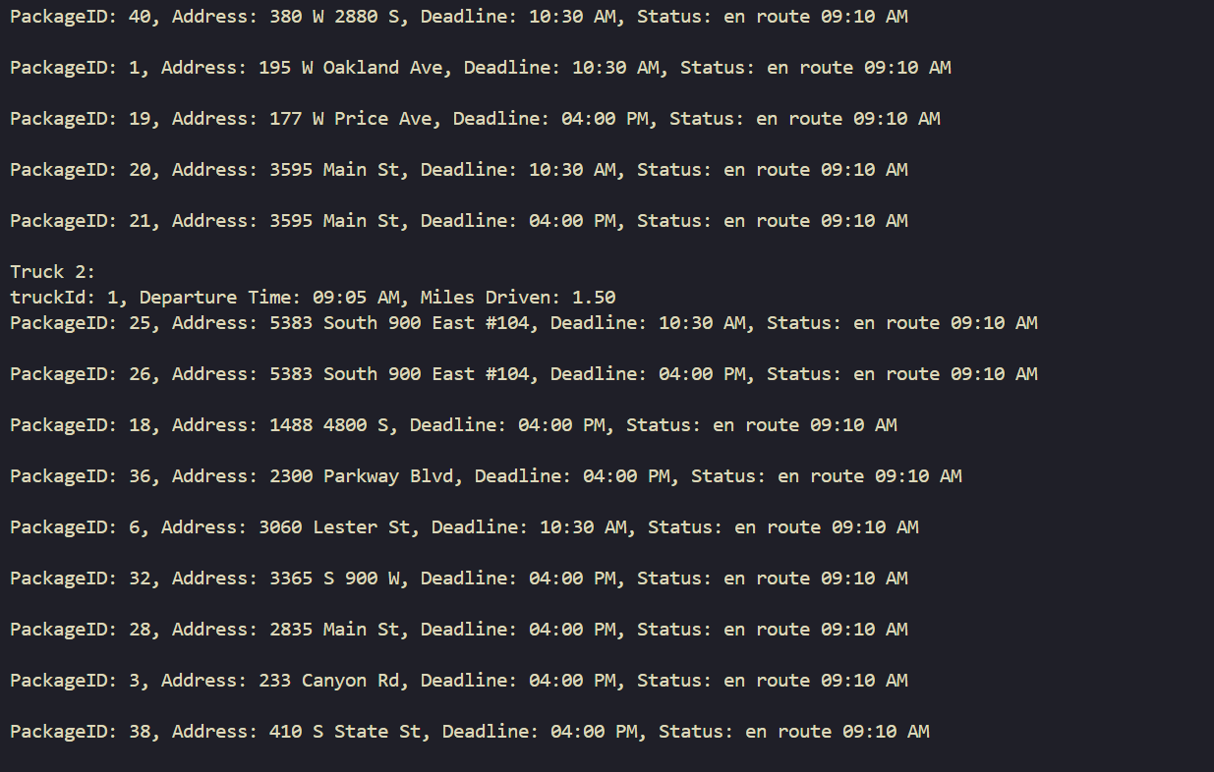

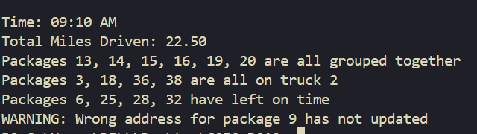

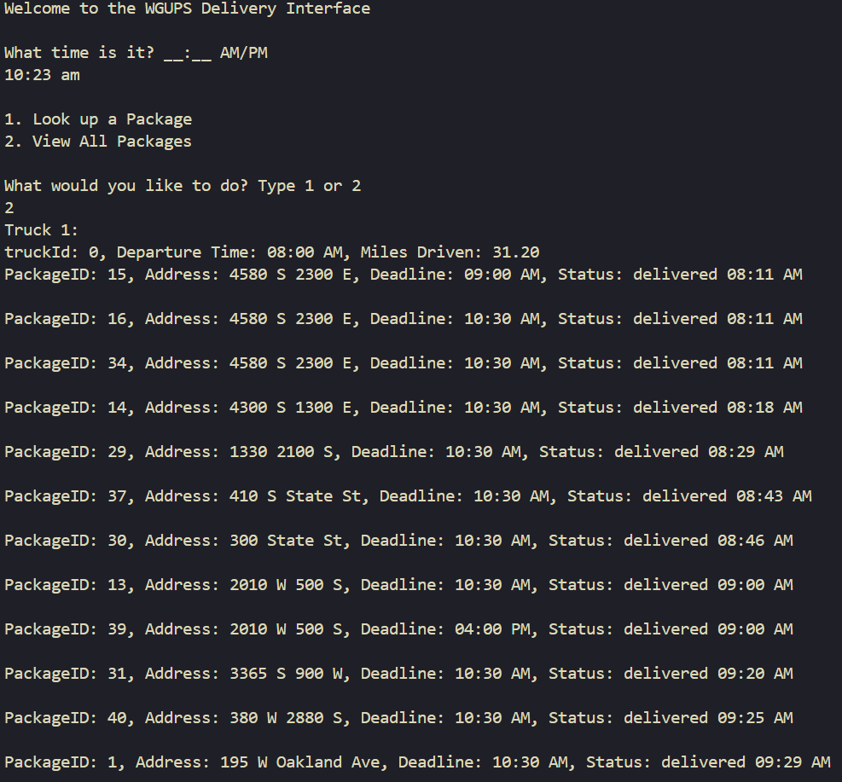

**G2**

All Packages on Each Truck

Time: 10:23 AM

Total Miles Driven = 55.50 mi

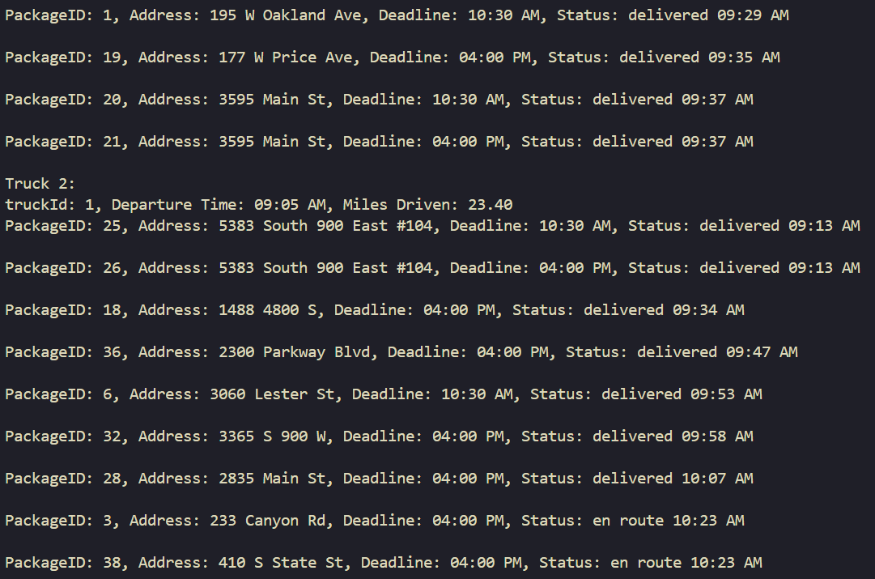

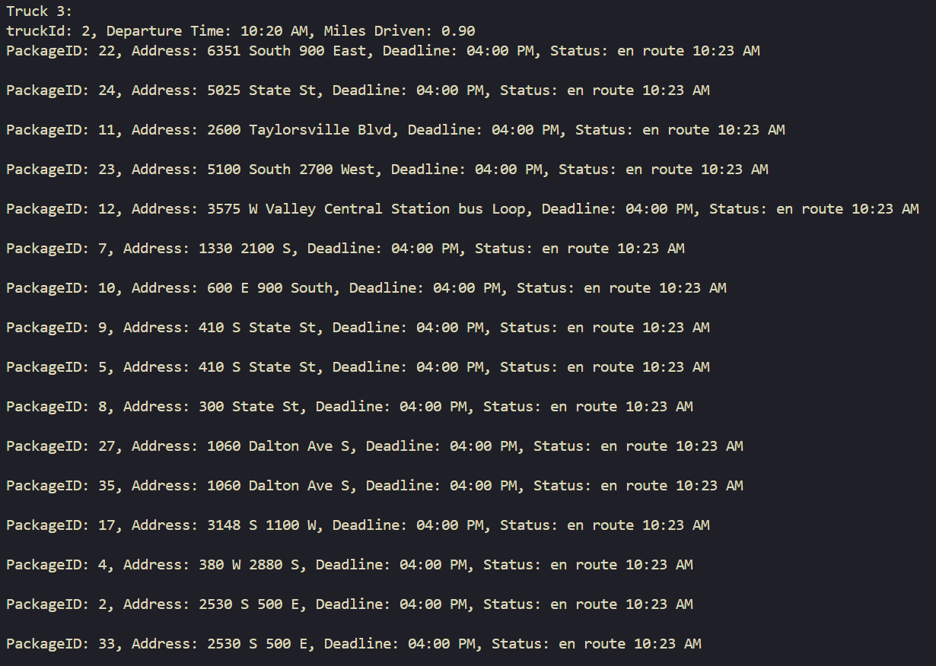

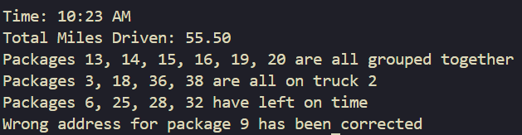

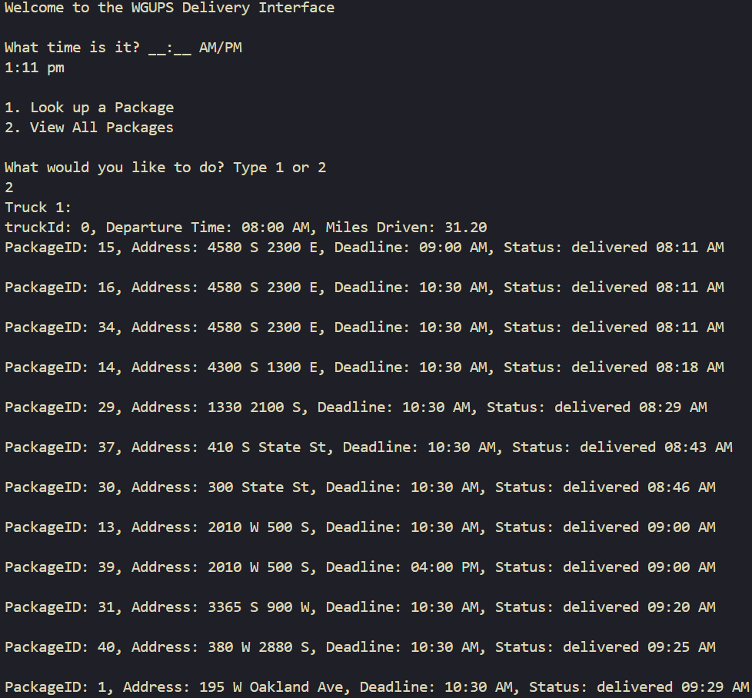

**G3**

All Packages on Each Truck

Time: 1:11 PM

Total Miles Driven = 108.40 mi

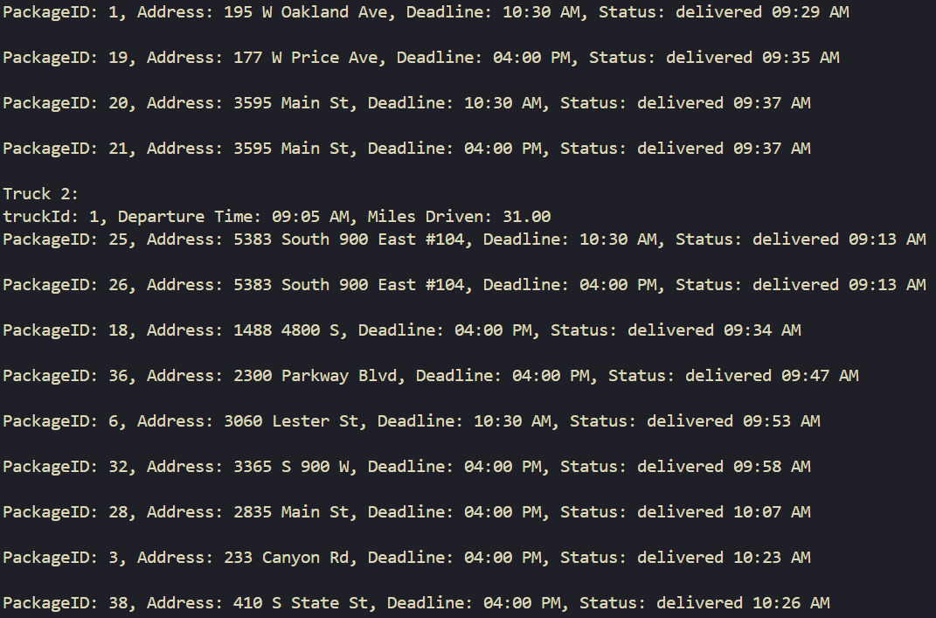

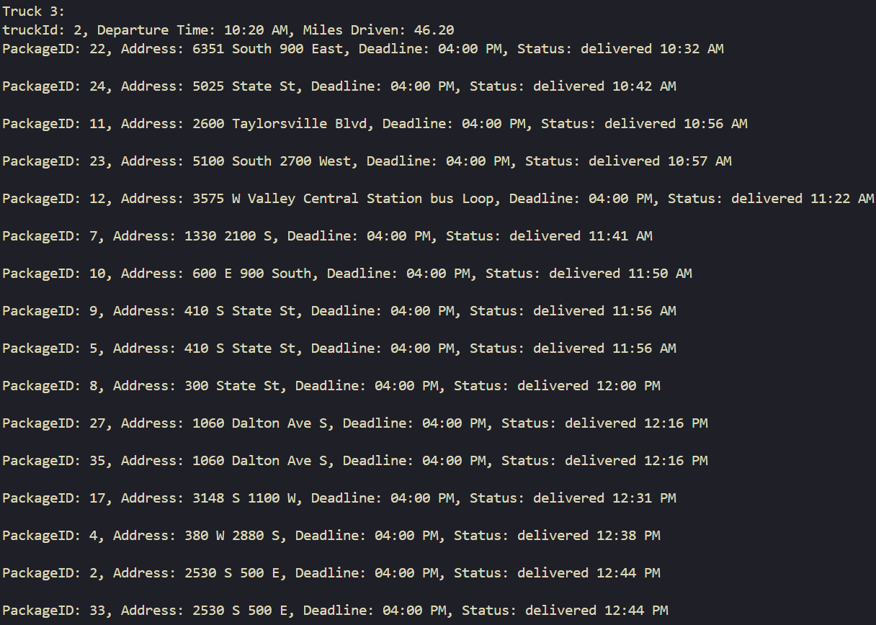

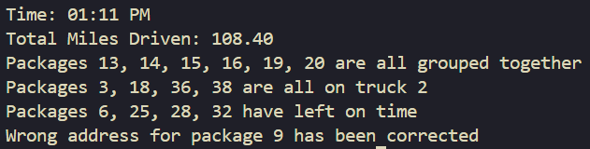

**H**

Code Execution

Time: 4:00pm aka EOD

Total Miles Driven = 108.40 mi

